A program of the pets’ medicine in the faculty of veterinary medicine
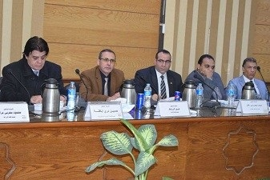
Benha University’s council, in its meeting yesterday under the presidency of prof.Dr. EL-Sayed EL-Kady, the University president approved on the bylaw which is proposed by prof.Dr. Muhammad Ghanem to make a new curriculum of the pets’ medicine which can lead to a bachelor of the surgery and the medicine of the pets.

