Benha University’s council approves on the research plan of the University

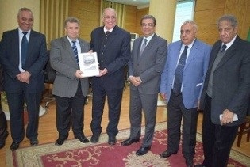
Benha University’s council, in its meeting yesterday under the presidency of prof.Dr. EL-Sayed EL-Kady, the University president approved on the research plans 2017-2022 which was proposed by prof.Dr. Maher Hasb EL-Naby, the University president’s chancellor of scientific research. The event was attended by the faculties’ deans, the deputies, the departments’ heads and the faculties’ members.

