The University’s council approves to establishes young leaders center
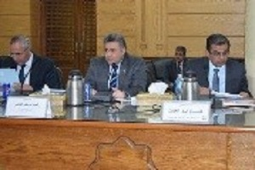
The University’s council approved, in its meeting yesterday, under the presidency of Prof.Dr. EL-Sayed EL-Kady, the University president on the suggestion to change the name of the youth development center to young leader’s center. The council heard to the vision of prof.Dr. Atef EL-Nemr, the general supervisor of the center who stresses on the importance of the center in enabling the youth culturally and socially by implementing many programs made by the experts.

