The supervising committee of carrying out the strategic plan finishes the assessment of 500 activities
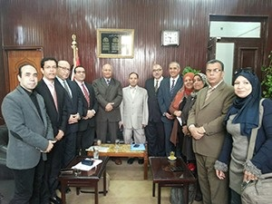
The unit of strategic planning in Benha University witnesses several activities to supervise carrying out the University’s strategic plan 2017-2022 under the auspices of prof.Dr. EL-Sayed EL-Kady, the University president. Prof. Dr. Gamal Abd EL-Aziz, the head of the Unit of strategic planning and the head of supervising committee of carrying out the strategic plan of the University says that the committee has finished the assessment of 500 activities.

