El-Gendy thanks Benha University for holding the population indicators forum
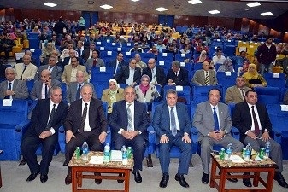
General, Abu baker EL-Gendy, the head of the central agency of mobilization and statistics stresses on the importance of holding the population indicators forum which is organized by Benha University as it is considered an initiative from an Egyptian University. EL-Gendy urges the Egyptian Universities to hold similar forums and He thanks Benha University for holding this forum.

