3 teams to supervise the strategic plan of Benha University

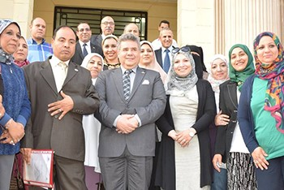
It has been agreed to form 3 teams to supervise the strategic plan of Benha University in the fields of post-graduate studies and the computerization of the University, the field of the students and alumni, the governance of the institutional performance and the continuous development and increasing the resources and the university’s capacity to accommodate more students. The teams are presided by prof.Dr. Alaa Amin, the former dean of the faculty of science, prof.Dr. Ibrahim Fouda, the dean of the faculty of education and prof.Dr. Gamal Sosa, the acting dean of the faculty of specific education.

