The veterinary medicine syndicate honors the top scholars in the faculty of veterinary medicine
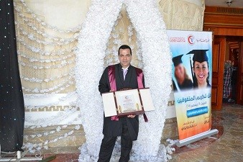
The veterinary medicine syndicate honors the top scholars in the faculty of veterinary medicine. It honors prof.Dr. Abd EL-Fattah Monged, the professor in the faculty of veterinary medicine for winning the award of the individuals and organizations 2016.

