Starting to revise the strategic planning in the faculties of Benha University
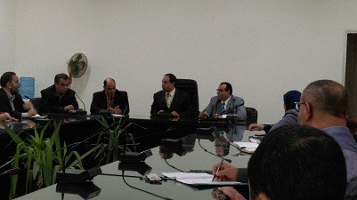
The unit of the strategic planning has finished of forming 16 special committees to revise the strategic planning in the university administration and the fifteen faculties. The special committee will start from 17-12-2017 and it lasts for four days and the special committees will revise the faculties’ plans in January and February.

