Benha University honors 250 researchers and students

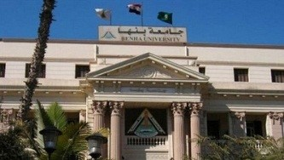
The scientific excellence day starts today on Sunday to honor 250 researchers and stduents. The ceremony is attended by prof.Dr. El-Sayed EL-Kady, the university president, prof.Dr. Gamal Ismail, the vice president of community service and environment development, prof.Dr. Hesham Abu EL-Enin, the vice president of post-graduate studies and research, the faculties’ members and the faculties’ deans and the students.

