Inaugurating a branch of Conifishuous institute in the faculty of arts
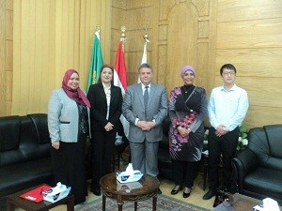
Prof.Dr. EL-Sayed EL-Kady, the university president witnesses signing the cooperation protocol between Benha University and Conifishuous institute in Cairo to establish a new branch of the institute in Benha University. The protocol was signed by prof.Dr. Abeer EL-Rabat, the faculty’s dean and prof.Dr. Rehab Mahmoud, the head of the institute.

