Excellence day ceremony to be held in Benha University
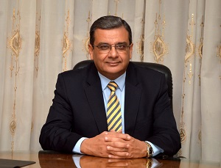
Prof.Dr. Hesham Abu EL-Enin, the vice president of post-graduate studies and scientific research states that there will be a ceremony, under the auspices of prof.Dr. EL-Sayed El-Kady, the university president, entitled “the excellence day” on Sunday, 3-12-2017 at the conferences hall in the faculty of commerce.

