Finishing the pillars of population committee in Benha University

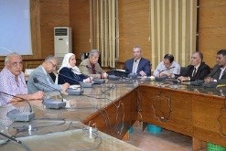
The preparation committee of the population forum which is organized by Benha University holds its meeting, under the presidency of prof.Dr. Hala Zayed, the dean of the faculty of computer and informatics, to discuss the topics of the forum like, education, health, economy, sociology, IT and architecture.

