A Last extension of the best links of the faculties’ members contest lasts for the end of November
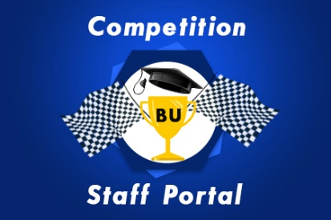
According to what the faculties’ members and teaching assistants and the meeting of the projects’ managers of IT on wendesday 8-11-2017, with prof.Dr. Hesham Abu EL-Enin, the vice president of the post-graduate studies and prof.Dr. Ghazi Assasa, the university president’s chancellor of IT, it has agreed upon to extend the best links of the faculties’ members contest to the end of November 2017.

