Abd EL-Halim EL-Kasaby is nominated to win Benha University’s award
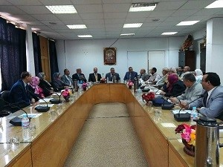
The faculty’s council approves, under the presidency of prof.Dr. Muhammad Abu Salim, the faculty’s dean to nominate prof.Dr. Abd EL-Halim EL-Kasaby, the lecturer of the faculty to win Benha University’s award.

