Benha University obtains the second place in the contest of programming in the student creative forum in the AUC

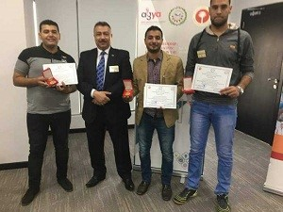
Benha university which obtains the second place in the contest of programming in the student creative forum at the AUC in UAE from 12-11-2017 to 15-11-2017.the research is entitled “designing and programming the 3D printers” of the student/Ahmed Reda in the faculty of engineering and it is conducted under the supervision of prof.Dr. Aref Ahmed, the deputy of the faculty of engineering.

