Benha University’s council visits 57357 hospital next Monday
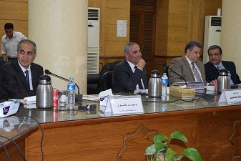
Benha University’s council decides, in its emergency meeting yesterday, to visit 57357 hospital next Monday morning to make sure that everything is up and running in the hospital and checks the role of the hospital in curing cancer-afflicted children.

