The result of the citation contests for july-2017
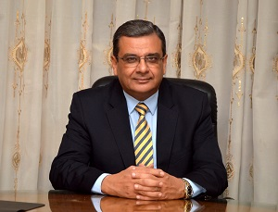
Prof.Dr. Hesham Abu EL-Enin, the vice president of post-graduate studies says that the supreme council of the international rankings of the universities has endorsed, in its last meeting, the report about the number of the citation through Google Scholar.

