A supreme committee to develop Benha university resources

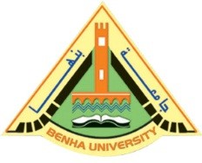
Prof.Dr. EL-Sayed EL-Kady, the university president issues a decree to form a supreme committee to develop Benha university resources. The committee includes prof.Dr. Safwat Zahran and prof.Dr. Hossam EL-Attar, the former Benha university presidents, prof.Dr. Soheir Sharaway, the former vice president, prof.Dr. Nabil Shedid, the former dean of the faculty of medicine, prof.Dr. Mahmoud Hamed, the former dean of the faculty of engineering, prof.Dr. Ashraf Tawfik and prof.Dr. Muhammad Mady, the professors in the faculties of law and agriculture respectively.

