The workshops on how to win the contest of the best links of the faculties’ members on Wednesday, 8-11-2017
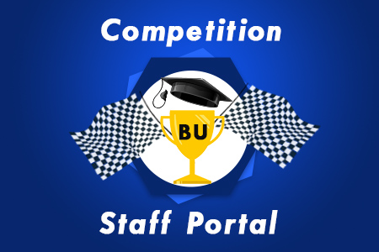
Under the auspices of prof.Dr. EL-Sayed EL-Kady, the university president and Prof.Dr. Hesham Abu EL-Enin, the vice president of post-graduate studies, the time to apply to the contest has been extended for two weeks. There is a work shop that will be held on Wednesday, 8-11-2017 in the building of the faculty of computer and informatics at 1 p.m. this lecture will be delivered by prof.Dr. Shady EL-Mashad and prof.Dr. Islam EL-Sharaway.

