A workshop for enabling the university hostels in Benha University to get the ISO

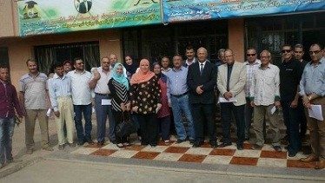
There is a workshop that has been held at the university hostels in Kafr-Saad in which prof.Dr. Abdel-Kader Abdel EL-Karim, the ISO official in Benha University, delivers a lecture on how to get the ISO and he sets an example of the administrations that get the ISO 9001. The participants are as follows: prof.Dr. Gamal Sosa, the university president chancellor of the university hostels affairs, prof.Dr. Ashraf Awad, the supervisor of the university hostels and Mr. Samy Mansur, the general manager.

