“The success of the Sino-Egyptian conference is the stimulus of holding more international conference” says EL-Kady
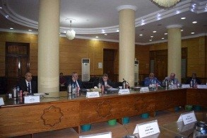
Prof.Dr. EL-Sayed EL-Kady discusses, in the university’s council, the results of the Sino-Egyptian conference that has been held in Benha University last week. He says that the success of the Sino-Egyptian conference is the stimulus of holding more international conference after Benha University has succeeding to reinforce its relationship with many Arab and foreign universities.

