El-kady urges the employees to hurry up in issuing the University’s Certificates

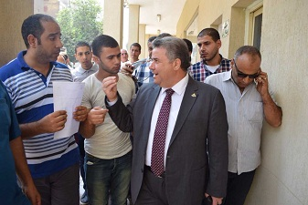
Prof.Dr. EL-Sayed EL-Kady, the university president and prof.Dr. Hesham Abu El-Enin, the vice president of post-graduate studies pay a sudden tour to the unified certificates center and they listen to the employees’ explanations on how the center works and issues the certificates. The university president urges the employees to hurry up in issuing the University’s Certificates.

