Carrying out the strategic plan of Benha University

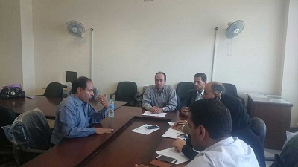
The unit of strategic planning is very active as the new academic year begins. The plans-revising committees hold its meetings to revise the strategic plans of the faculty of law and the faculty of commerce after revising the plan of the faculty of nursing in addition to conducting many activities according to the statements of prof.Dr. Gamal Abd EL-Aziz, the head of the strategic planning unit in Benha University.

