Benha university president stresses on the importance of the student activities during his meeting with the faculties’ secretaries
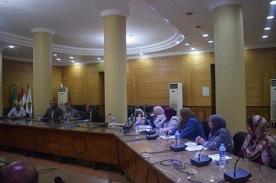
Upon his return from China, prof.Dr. El-Sayed EL-Kady holds a meeting, yesterday morning, with the faculties’ secretaries, prof.Dr. Gamal Ismail, the vice president of community service and environment development and Mr. Wahid Khalawy, the university’s secretary. They discuss the university’s faculties preparations of the new academic year as the university president stresses on the importance of the student activities.

