A committee to revise the strategic plan of the faculty of law
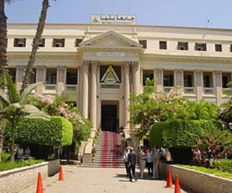
Prof.Dr. Gamal Abd EL-Aziz, the head of the strategic planning in Benha University receives the strategic plan of the faculty of law and he issues a decree that this plan should be revised to know if it matches the strategic plan of the university 2017/2022. He forms a committee under the presidency of prof.Dr. Afaf Desoky to revise the plan and the committee should finish it and submit a report during one week.

