A cooperation protocol to be signed between Benha University and the Egyptian Cabinet information and decision support center

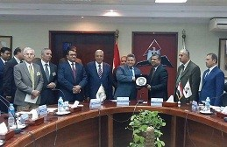
Prof.Dr. EL-Sayed El-kady, the university president, the university president and prof.Dr. Hossam EL-Gamal, the head of the Egyptian Cabinet information and decision support center sign a cooperation protocol at the center building in new Cairo.

