El-kady congratulates the students on their success and promises them with an excellent academic year

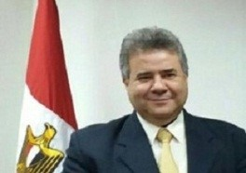
Prof.Dr. EL-Sayed EL-Kady, the university president congratulates the students on their success heaping praise on their effort. He also congratulates the parents of the students stressing that the students’ success is the result of their parents support. At last, he promises them with an excellent academic year that is better than the former academic year on the different apparatuses.

