Congratulations … Benha University ranks among the sixth top Egyptian universities in the Spanish ranking (Webometrics) in July, 2017

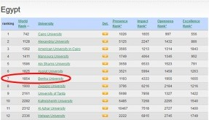
The results of the Spanish ranking (Webometrics) have been revealed in July, 2017 as follows:
- Benha University ranks the sixth place among the Egyptian governmental universities and ranks the seventh place among the Egyptian private universities.
- Benha University is in the twenty-one place among the Arab Universities.
- Benha University is in the twenty-two place among the African universities.
- Benha University in the 1854 place on the international apparatus.

