In the first days of the feast: El-Kady visits the patients of the university hospitals

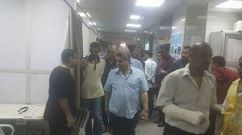
In the first days of the feast, Prof.Dr. EL-Sayed EL-Kady, the university president is keen on visiting the university hospitals for more than three hours as he inspects the departments of the hospital. He also pays a visit to the patients of the university hospital and cordially wishes them a speedy recovery.

