El-kady meets with the Kuwaiti national delegation of accreditation and quality assurance in Cairo

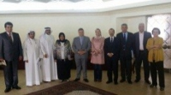
Prof.Dr. EL-Sayed El-Kady, the university president meets with the Kuwaiti national delegation of accreditation and quality assurance in presence of the chancellor/ Ahmed EL-Meteri, the Kuwaiti cultural chancellor in Cairo and they discuss the required procedures to achieve a quality educational process in the university’s faculties. The meeting is attended by prof.Dr. Hussien Abaza, the dean of the faculty of physical education, prof.Dr. EL-Sayed Fouda, the dean of the faculty of law, prof. Dr. Abeer EL-Rabat, the dean of the faculty of arts, prof.Dr. Eid Hemida, the dean of the faculty of commerce

