Using the budget of 103 Million pounds to develop the university’s faculties

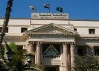
Benha University’s council discusses, in its meeting today, the report of prof.Dr. Karim Rashwan, the head of the center of the geometrical counseling at the faculty of engineering/ Shubra. He presents in this report the university’s success in using the budget of 103 Million pounds to develop the university’s faculties.

