For the first time: Establishing a unit of transplantation in the faculty of medicine
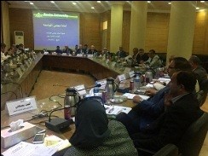
The university’s leader’s council, under the presidency of prof.Dr. El-Sayed EL-Kady, The university president approves on the suggestion of prof.Dr. Mahmoud Abd EL-Sabour, the dean of the faculty of medicine to establish a unit of transplantation in the faculty of medicine in Benha university’s hospitals.

