The comprehensive convoys is mostly welcomed by the inhabitants of EL-Kashich Village in Shebin-EL-kantar

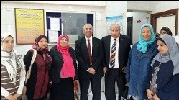
The comprehensive convoys, which were organized by the sector of the community service and environment development under the auspices of prof.Dr. EL-Sayed EL-Kady, the university president, prof.Dr. Gamal Ismail, the vice president of community service and environment development and prof.Dr. Muhammad EL-Sayed, the head of IT center and the coordinator of the convoys, are mostly welcomed by the inhabitants of EL-Kashich Village in Shebin-EL-kantar.

