“Egypt witness’s unprecedented accomplishments” says the university president in the inauguration of the scouting festival of Benha university’s students

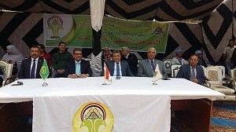
Prof.Dr. El-Sayed EL-Kady, the university president inaugurates the scouting festival of Benha university’s students in the presence of prof.Dr. Hesham Abu Enin, the vice president of the post-graduates studies and research, prof.Dr. Khalid Esawi, the general coordinator of the students activates the faculty’s deans and the faculties’ professors. The university president says that youth are the future of Egypt urges them to work hard and stands firm and united in front of the rumors that may destroy the state. He also expresses his confidence in the youth to overcome the difficulties and Egypt is currently witnessing unprecedented accomplishments.

