Benha University’s competition of athletics

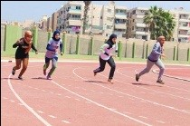
The general administration of youth care organizes the university’s competition of athletics among the students which includes running for 100, 200, 400, 800, 1500 meters, long jumping and the Javelin. Mr. Ibrahim Abd EL-Allah, the head of the general administration of sport activities in the university says that the faculty of physical education wins the first place, the faculty of education wins the second place and the faculty of science wins the third place.

.

