The certificates center is the only way to issue the university’s certificates

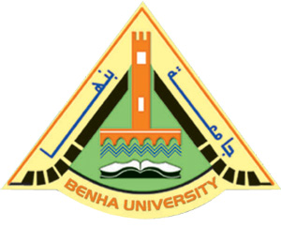
Benha University warns against using the university’s name or any of its faculties to issue a fake certificate and stresses that the certificates center is the only way to issue the graduates’ certificates for all students. The university president warns that the university will not seize any effort to inform the legal authorities about faking the certificates.

.

