EL-Kady asserts that the university hospitals are up and running

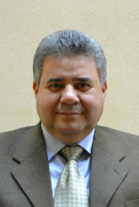
In a phone call, prof.Dr. EL-Sayed El-Kady, the university president asserts that the university hospitals are up and running and the hospitals are providing a quality healthcare to the patients. The university president says that the problem of the strike has been solved by contacting the dean of the faculty of nursing and the deputies of the faculty to provide those who do the job of nurses as per what has been agreed upon with the dean of the faculty of medicine, the faculties’ deputies and the manager of the university hospitals.

.

