EL-Kady meets with the president of EL-Sadat University

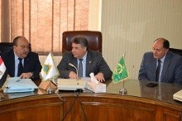
Prof.Dr. EL-Sayed EL-kady, the university president meets, in his office, prof.Dr. Essam EL-Din Metwaly, the acting president of EL-Sadat University and they discuss the cooperation in different aspects between both of them.

.

