“I’m available for anyone who gets hurt from our hospitals and we are committed to provide a very good healthcare service”

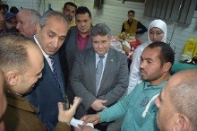
Prof.Dr. El-Sayed El-Kady, the university president visits the university hospitals, inspects some departments in the hospital and listens to the complaints of the patients. He was accompanied by prof.Dr. Mahmoud abd el-Sabour, the dean of the faculty of medicine, prof.Dr. Yosry el-Said, the manager of the university hospitals, prof.Dr. Muhammad abdo, prof.Dr. Muhammad EL-Gazer and prof.Dr. Muhammad Farag.
.

