The Meeting of the IT managers in the faculty of engineering/ Shubra

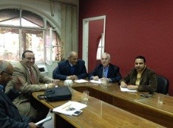
The IT managers held their meeting, under the presidency of prof.Dr. Ghazi Assasa, the university president’s chancellor of the IT, on Wednesday, 8-3-2017 at the department of mechanical engineering as follows:
- Prof.Dr. Muhammad Muhammady Ghanem, the vice executive manager of IT
- Prof.Dr. Shady Yehia El-Meshed, the managers of E-portal
- Prof.Dr. Mustafa El-Sayed, the vice manager of the MiS
- Prof.Dr. Muhammad Ibrahim attends on behalf of prof.Dr. Lotfy Abu Salim, the manager of IT training project.
- Prof.Dr. Ahmed Atia, the manager of IT in the faculty of engineering/ Shubra.

