Filling a position in the commissariat of the African union 2017

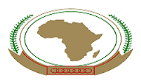
The general administration of the international cooperation in the ministry of higher education announces that there is a job vacancy to fill a position of senior policy officer- education division at the administration of science and technology in the commissariat of the African union. The deadline is 11-3-2017 and the applicants can register via the following link:
http://www.aucareers.org

