“The union is the right path to safe Egypt” says the university president

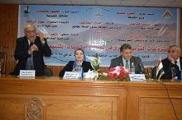
Prof.Dr. El-Sayed El-kady, the university president asserts that we lives in a safe environment because of those who protect us stressing that the union is the right path to safe Egypt. This statement concurs with the university president’s presence at the forum entitled “the national big projects and the possibilities of future development” in the faculty of arts. The forum is held under the auspices of prof.Dr. Helmy El-Namnam, the minister of culture and head of the supreme council of the culture, general/ Mahmoud Ashmawy, the Qulubia governor. The forum is attended by prof.Dr. Gamal Ismail, the vice president of community service and environment development, prof.Dr. Abeer El-Rabat, prof.Dr. Fathy abu Enaya, the professor of Geography and the president of Beirut University and prof.Dr. Azza abd alla, the rapporteur of the forum.

