A workshop to warn the employees against corruption
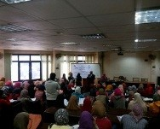
Benha University organizes many workshops in its faculties to warn the employees against corruption from 18-2-2017 to 28-2-2017. These workshops are in the frame of the university’s plan to fight corruption. These workshops are held under the auspices of the minister of higher education and prof.Dr. El-Sayed El-kady, the university president.

