The Head of the quality Project in Benha University’s meets the Employees of 14 Departments to be accredited by the accreditation authority

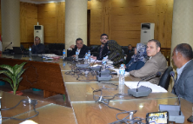
Prof.Dr. Abd El-Kader Abd el- Kareem, The head of the quality project meets the employees of 14 departments to be ready for the visit the of the quality delegation on Sunday, 26-2-2017 as these departments will be accredited by the national authority of quality assurance and accreditation of education.

