Benha university president welcome the American writer Marisa Silver

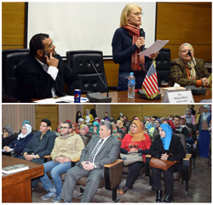
The American writer Marisa Silver stressed that she was surprised by the Egyptian students’ passion of curiosity and that contradicts what the American people know about the Egyptians. This statement concurs with her visit to Benha University and having a meeting with prof.Dr. El-Sayed EL-Kady, the university president in the presence of the several students and the faculties’ members of the English language department from the faculty of arts and the faculty of education. Marisa Silver adds that she visits Egypt from 11-2-2017 to 17-2-2017 where she participates in Cairo literary festival, attends two literary soirees and visits Cairo University, Ein-Shams University and Benha University. She also says that she pay a great attention to women issues and the hard circumstances that women live in.

