Honoring the Heroes of the Faculty of Nursing in Benha University’s Leaders Council

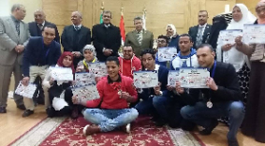
In Benha university’s leaders council, Prof.Dr. El-Sayed El-Kady, the university president and the head of the council honors the students of the faculty of nursing who participate in the activities in the second forum for the students of the faculty of nursing in the Egyptian universities that is held in the University of Assiout from 29-1-2017 to 2-2-2017. The university president honors the supervision team- prof.Dr. Mahboba Sobhy abd El-Aziz, prof.Dr. Hend abd- Allah El-Sayed, prof.Dr. Eman Sobhy and Mr. Ali Kamal Ali, the youth care supervisor. The honoring ceremony is attended by prof.Dr. Gamal Ismail, the vice president of community service and environment development, prof.Dr. Hesham Abu EL-Enin, the vice president of post-graduate studies and research, prof.Dr. Howyda abd EL-Hamid, the dean of the faculty of nursing, prof.Dr. Ahmed Rashad, the supervisor of the council secretariat and prof.Dr. Khalid Esawi, the general coordinator of the students activates in Benha University

