On the Road to ISO: a Meeting with 14 Departments in Benha University

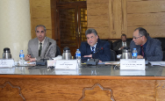
Prof.Dr. EL-Sayed EL-Kady, the university president meets with the heads of 14 Departments, on Wednesday noon, among 45 departments in Benha University to discuss the procedures taken in these departments to obtain the ISO 9001 of the year 2008. These departments are as follows: the public relationships department, the cultural and scientific department, the post-graduate studies department, the department of purchases, the department of storehouses, the department of councils secretariat, the department of the faculties’ members, the HR department, the department of educational and student affairs, the department of university president office, the department of Information and decision making center, the department of transportation and the maintenance department.

