“Our Aims is to achieve the President’s vision for the Youth of Egypt” says the University President in the Inauguration of the Agricultural Round no.39

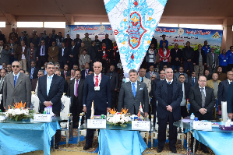
Prof.Dr. El-Sayed El-Kady, the university president inaugurates the activities of the agricultural round no.39 which takes place at the center of youth development center in the faculty of agriculture /Moshtohor. This event is held in the presence of prof.Dr. Gamal Ismail, the vice president of the community service and environment development, prof.Dr. Hesham Abu EL-Enin, the vice president of the post-graduate studies and the research, several deans of the faculties and the institutes that participate in the agricultural round.

