In a Sudden Visit … the University President inspects the Controls and the New Programs in the Faculty of Veterinary Medicine
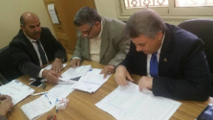
Prof.Dr. EL-Sayed El-Kady, the university president suddenly visits the faculty of veterinary Medicine in Moshtohor. He inspects the controls and the new programs in the faculty and he was accompanied by prof.Dr. Muhammad Abu Salim, the faculty’s dean and the faculty’s deputy of education and students affairs.

