The University President inspects the Exams in the Faculty of Commerce
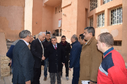
Prof.Dr. El-Sayed El-Kady, the university president inspects the exams in the faculty of commerce and he is accompanied by prof.Dr. Eid Hemida, the faculty’s dean. The university president makes sure that the exams are up and running and the rules set forth by the university council are strictly followed.

